**Hardware ID (Medium)**

**We found a device left at a local library. What can you figure out about it from these pictures?**

* Download the images.
* Google the chip followed by the keyword “data sheet.”

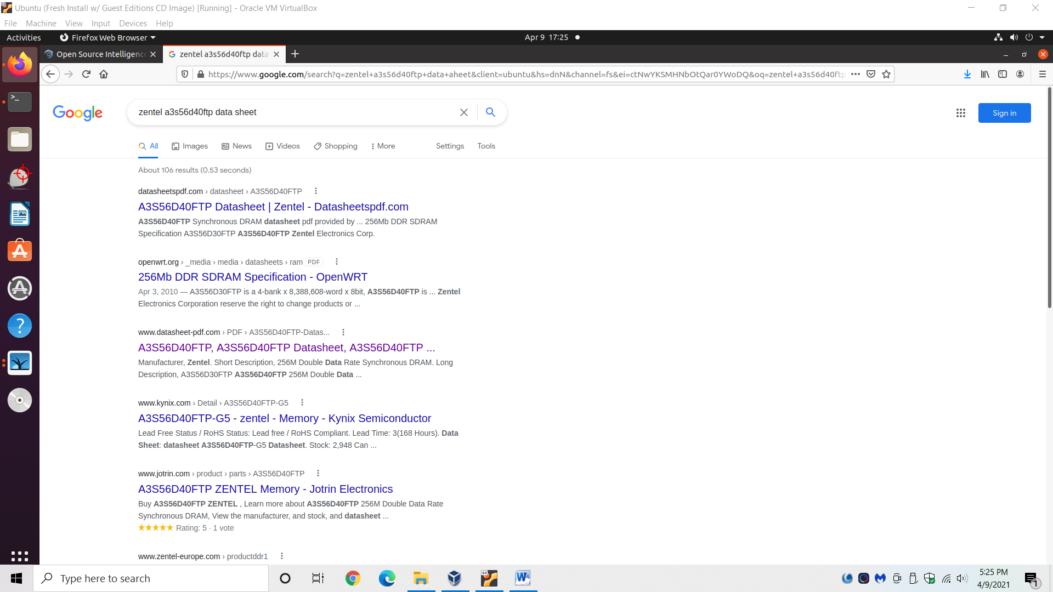

* All info can be found by downloading the chip’s datasheet, or by using websites like *datasheet.com*.

**\***Datasheets are helpful to look up detailed info on any piece of hardware! Make sure to include it any queries about hardware when researching specs.

**What Instruction Set Architecture does Chip3 support?**

Answer: MIPS16

**How many Ethernet ports are built into the integrated switch on Chip 3?**

Answer: 5

**What interface do Chip1 and Chip3 use to communicate with the host device?**

Answer: PCIE

**What is the maximum clock speed of Chip 2 (in MHz)?**

Answer: 250

**What is the maximum amount of flash storage that Chip 3 supports (in MB)?**

Answer: 16